***A Mini Project Report on***

**Expense Tracker And Prediction**

**(Expenzo)**

**T.E. - I.T Engineering**

**Submitted By**

**Purvesh Gangapurkar 20104063**

**Ambadas Malegave 20104112**

**Rahul Patil 20104073**

**Under The Guidance Of**

**Prof. Mansi Choche**



**DEPARTMENT OF INFORMATION TECHNOLOGY**

A.P.SHAH INSTITUTE OF TECHNOLOGY

G.B. Road, Kasarvadavali, Thane (W), Mumbai-400615

UNIVERSITY OF MUMBAI

**Academic year: 2022-23**

**CERTIFICATE**

This to certify that the Mini Project report on Loan Prediction System has been submitted by **Purvesh** **Gangapurkar** **(20104063)**, **Rahul Patil (20104073)** and **Ambadas Malegave (20104112**) who are a Bonafide students of A. P. Shah Institute of Technology, Thane, Mumbai, as a partial fulfilment of the requirement for the degree in **Information Technology**, during the academic year **2022-2023** in the satisfactory manner as per the curriculum laid down by University of Mumbai.

Prof. Mansi Chaoche

Guide

Dr. Kiran Deshpande Dr. Uttam D.Kolekar

Head Department of Information Technology Principal

External Examiner(s)

1.

2.

Place: A.P.Shah Institute of Technology, Thane

Date:

**ACKNOWLEDGEMENT**

This project would not have come to fruition without the invaluable help of our guide **Prof. Mansi Choche**. Expressing gratitude towards our HOD, **Dr. Kiran Deshpande**, and the Department of Information Technology for providing us with the opportunity as well as the support required to pursue this project. We would also like to thank our teacher **Prof. Charul Singh** who gave us her valuable suggestions and ideas when we were in need of them. We would also like to thank our peers for their helpful suggestions.

**ABSTRACT**

This project is based on an expense and income tracking system. This project aims to create an easy, faster and smooth tracking system between the expense and the income. This project also offers some opportunities that will help the user to sustain all financial activities like digital automated dairy. So, for better expense tracking system, we developed our project that will help the users a lot. Most of the people can’t track their expenses and income one way they face a money crisis, in this case daily expense tracker can help the people to track income-expense day to day and making life tension free. Money is the most valuable portion of our daily life and without money we will not last one day on earth. So using expense tracker application is important to load a happy family. Expense tracker helps the user to avoid unexpected expenses and bad financial status. This project will save time and provide a responsible lifestyle. The expenses tracking website is a digital platform designed to help individuals manage their finances effectively. The website allows users to input and track their expenses, set budgets, and receive notifications when they exceed their budget limit. This system helps users to better understand their spending habits and make informed decisions regarding their financial future. Additionally, the website provides users with detailed reports and insights into their spending patterns, enabling them to identify areas where they can cut back on expenses and save more money. The platform also offers personalized financial advice and recommendations to help users achieve their financial goals. Overall, the expenses tracking website is an efficient and user-friendly platform that provides individuals with the tools and resources necessary to manage their finances effectively. By enabling users to track expenses, set budgets, and receive personalized financial advice, the website can help individuals make informed financial decisions and achieve their financial goals.

**TABLE OF CONTENTS**

1. Introduction…………………………………………………………………………6
   1. Purpose............................................................................................................. 7
   2. Problem Statement…………………………………………………………….8
   3. Objectives...........................................................................................................8
   4. Scope.................................................................................................................. 9
2. Literature Review…………………………………………………………………..10
3. Proposed System………............................................................................................11
   1. Features and Functionality………………………………………………........12
   2. Algorithm & Working ………………………………………………………..13
4. Requirements Analysis...............................................................................................17
5. Project Design.............................................................................................................18
   1. Block Diagram….……………………………………………………….……. 18
   2. Use Case diagram …………...………………………………...……………….19
   3. DFD (Data Flow Diagram) ………………………………………………...….19
6. Technical specification……………...………………………………...……………..20
7. Project Scheduling.......................................................................................................21
8. Implementation………………………………………………………………………22

9. Result and Discussion…………………………………………………………………17

1. Conclusion and FutureScope.......................................................................................18

References

**CHAPTER 1**

**INTRODUCTION**

Nowadays, every technical field is trying to style human life at ease. With the rapid growth in the use of the internet and the technologies associated with it, several opportunities are coming up in the web or mobile application. In today’s busy and expensive life we are in a great rush to make money. But at the end of the month we broke off. As we are unknowingly spending money on little and unwanted things. So, we have come over with the idea to track our earnings. The application “Expense Tracker” is developed to manage the daily expenses in a more efficient and manageable way. By using this application we can reduce the manual calculations of the daily expenses and keep track of the expenditure.

Expense Tracker System is designed to keep a track of Income-Expense of an individual on a day-to-day basis. This System divides the Income based on daily expenses.  Expense Tracker aims to help everyone who are planning to know their expenses and save from it.

Budgeting systematically and Expense Tracking takes a crucial role in managing the expenses. Expense tracking will bring in several advantages for an individual. The expense tracker will help any organization to deal with all their expenses more efficiently. By using software for managing expense tracking will help to control unnecessary expenses. There are several benefits and advantages of using online expense trackers, expense tracking makes any organization run faster and smoother.

The tracker will become an important tool for any individual to improve the expense management. Our Expense tracker system will provide the reference links according to their expense categories. This reference videos will help the user to know and understand particular expenses and to invest in proper options according to their expense categories.

1. **Purpose:**

We can use our Expense tracker system to manage the expenses correctly. It will be very helpful for the user to save his/her money in a convenient way. It will also be very useful for user in investing the money in the right direction.

We can use our Expense tracker system to manage the expenses correctly. It will be very helpful for the user to save his/her money in a convenient way. It will also be very useful for user in investing the money in the right direction.

We can use our Expense tracker system to manage the expenses correctly. It will be very helpful for the user to save his/her money in a convenient way. It will also be very useful for user in investing the money in the right direction.

The main purpose of the Expense tracker is to give a perfect idea about the expenses according to the income. Expense tracker also suggests ways to save money accordingly or to invest the money according to their expense category.

1. **Problem Statement:**

The main purpose of Expense tracker is to give an perfect idea about the expenses according to the income. Expense tracker also suggest the ways to save the money accordingly or to invest the money according to their expense category.

The main purpose of Expense tracker is to give an perfect idea about the expenses according to the income. Expense tracker also suggest the ways to save the money accordingly or to invest the money according to their expense category.

of the major problem identified in this current time was, there were no such platform which will keep record of their expenses.

1. **Objectives:**

* To keep a track of Income-Expense on a day-to-day basis.
* To keep an accurate record of your money inflow and outflow.
* To save money for pre-defined expenses which will help planning on your future investments.
* To keep track of daily expenses and budgeting.
* To help everyone who are planning to know their expenses and save from it.
* To know where the money is going.
* To provide Graphical overview of expenses.
* To Minimize manual effort with daily record of expenditures and incomes.
* To provide Immediate and easy retrieval of report.

1. **Scope:**

The main purpose of Expense tracker is to give an perfect idea about the expenses according to the income. Expense tracker also suggest the ways to save the money accordingly or to invest the money according to their expense category.

* Can be use by anyone who are willing to manage their expenses.
* Aiming to save the money for the future investments and many more.
* There is not any range criteria or any kind of profession or gender are focused , it will be used hugely.
* In a very short time, the collection will be obvious, simple and sensible.
* This application can be useful for users to increase their savings as they are going physical to digital.

**CHAPTER 2**

**LITERATURE REVIEW**

|  |  |  |  |  |  |  |
| --- | --- | --- | --- | --- | --- | --- |
| **Sr.no** | **Title** | **Author(s)** | **Year** | **Algorithms** | **Limitations** | **Result** |
| **1** | Predicting Future Expenses using Machine Learning | Shivani Gupta, Pankaj Yadav, and Rajesh Yadav | 2019 | Long Short-Term Memory (LSTM) Neural Network | Only trained and tested on a small dataset | The model achieved an accuracy of 93.24% in predicting future financial status |
| **2** | Forecasting Daily Expenses Using Machine Learning and Data Analytics | Ashok Kumar Sharma and Shilpa Choudhary | 2020 | Gradient Boosting Decision Tree (GBDT) | Limited to predicting daily expenses only | The model achieved an accuracy of 83.6% in predicting future daily expenses |
| **3** | A Personalized Expense Tracking System with Future Expense Prediction | Alina Mustafina, Andrey Somov, and Tatiana Baidyk | 2021 | Bayesian Networks | Only tested on a small dataset | Predicting future monthly expenses  85% accuracy |

**CHAPTER 3**

**PROPOSED SYSTEM**

To reduce manual calculations, we propose an application which is developed to manage expense. This application allows users to maintain a digital automated diary.

This system is a bunch of benefits from various points of view. This online application enables the end-users to register to the system online,  Expense Tracker application which will keep a track of Income-Expense of a user on a day to day basis. This application takes Income from user and divides in daily expense allowed.

Expense tracking application will generate report at the end of month to show Income-Expense via multiple graphs. Their will be categories on the basis of expenses which will give an clear idea about the flow of the money and will provide suggestions. By Tracking Expenses, it will be very helpful for the people to do their budget planning. By using our Expense tracker system, everyone can save and manage their expenses.

* + 1. Security of data.
    2. Ensure data accuracies.
    3. Minimize manual data entry.
    4. Minimum time needed for the various processing.
    5. Greater efficiency.
    6. User-friendliness and interaction.
    7. Minimum time required.

**3.1 Features & Functionality:**

1. **User Friendly and Easy To Manage :**
   * Simple and interactive user interface.
   * All important information displayed at one place i.e Dashboard
2. **Expense Categories :**

* Manage the information according to their Categories.

1. **Data Search :**

* Provides the searching facilities based on various factor such as expense and types .

1. **Graph and Pie chart :**

* Graph and Pie chart is displayed to make the understanding more clear.

1. **Printable Expense report :**

* You can easily export PDF for the Expense report.

1. **Suggestions :**

* Suggestions are provided based on your expenses.

1. **Rating :**

* Users can relate the application based on their experience.

**3.2 Algorithm And Working:**

In this innovative expense tracker app, we're utilizing the power of advanced machine learning techniques to enhance your experience. Our app employs linear regression for accurate categorical predictions and leverages random forest regression to forecast expenses for the next 6 months.

* 1. **Linear Regression for Categorical Prediction :**

Linear regression is a machine learning algorithm used to model the relationship between a dependent variable and one or more independent variables. It estimates the coefficients of a linear equation to make predictions based on input values. It is simple, effective, and widely used in various fields.

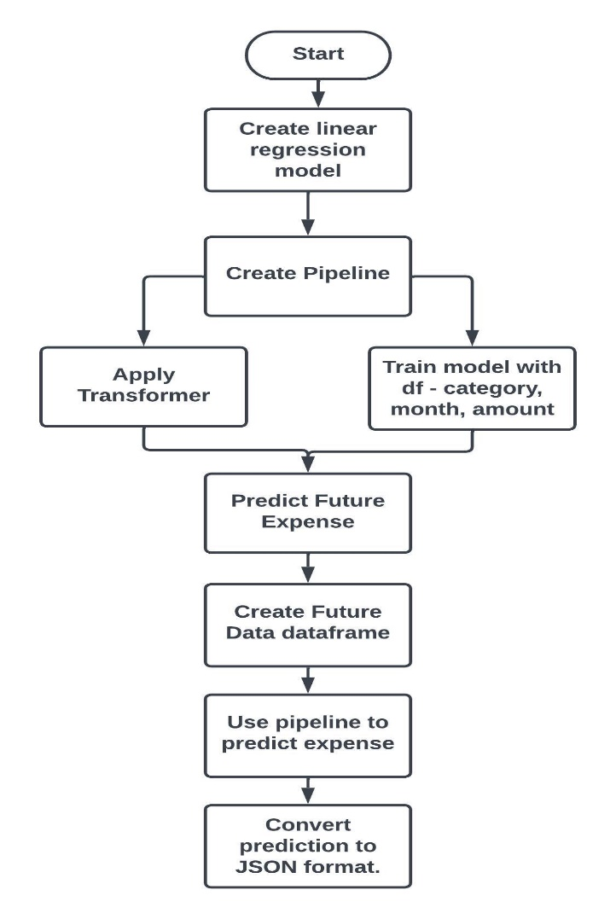

* **Working:**
  1. Data is loaded from the request payload, containing historical expenses for different categories.
  2. The data is preprocessed using a ColumnTransformer with OneHotEncoder to convert categorical variables into numerical representations.
  3. The preprocessed data is used to train a LinearRegression model, which is incorporated into a pipeline for streamlined processing.
  4. The pipeline is fitted to the training data, transforming columns and training the model on the target variable.
  5. Future expenses for each category are predicted using the trained model and stored in a dictionary.
  6. The predicted expenses are formatted as a dictionary with keys in the format of "month-category".
  7. The predicted expenses are returned as a JSON response for financial planning and decision-making purposes.
* **Advantages of Linear Regression Over other Algorithms :**
  + 1. **Interpretability:** Linear regression provides interpretable results, allowing us to understand the relationship between input features (e.g., category and month) and predicted expenses in a straightforward manner. This is in contrast to some other algorithms, such as black-box models like deep learning neural networks, which may provide accurate predictions but lack interpretability, making it difficult to explain the predictions to stakeholders.
    2. **Efficiency:** Linear regression is computationally efficient and can handle a large number of samples and features. This makes it suitable for processing large datasets, which is common in financial data. On the other hand, some other algorithms like support vector machines or k-nearest neighbors may have higher computational costs or suffer from scalability issues.
    3. **Feature Importance:** Linear regression allows for easy identification of the most important features (e.g., categories) that influence the predicted expenses. This can provide valuable insights for decision-making and financial planning. In contrast, some other algorithms may not provide explicit feature importance information, making it harder to interpret and prioritize the factors that contribute to the predictions.
    4. **Availability of Libraries:** Linear regression is widely available in popular data analysis and machine learning libraries, making it easy to implement and integrate into existing code, compared to some other algorithms which may have limited availability or require additional setup.
  1. **Random forest to predict expenses for 6 consecutive months :**

Random Forest Regressor is a popular ensemble learning algorithm for regression tasks, predicting continuous numerical values. It combines multiple decision trees trained on random data subsets to create a robust and accurate model. It handles complex data patterns, mitigates overfitting, and is widely used in domains like finance, healthcare, and marketing due to its high accuracy, scalability, and interpretability.

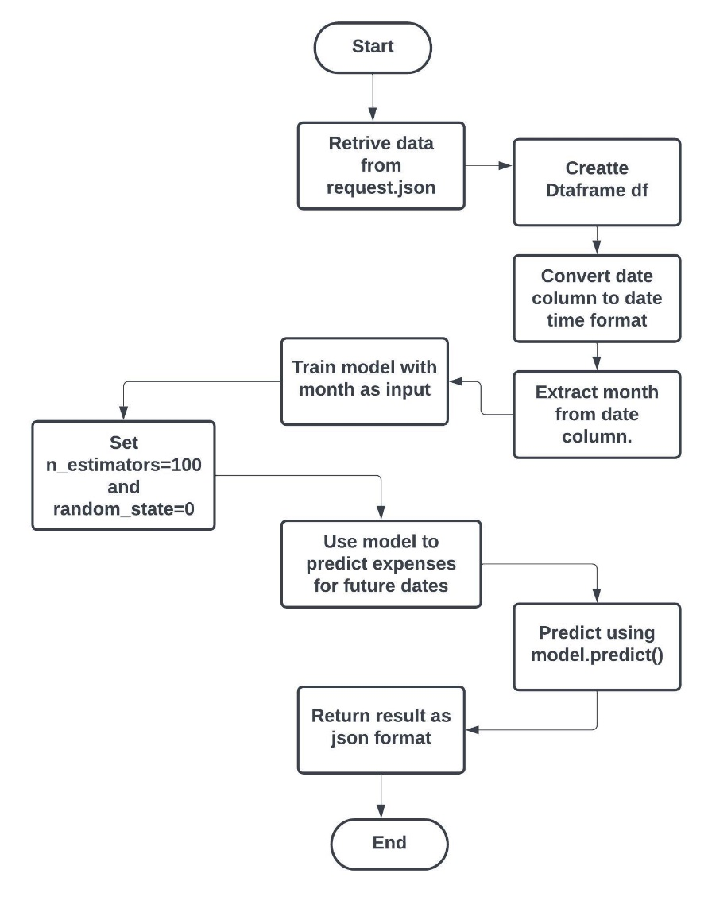

* **Working :**
  + 1. Load data from request payload and create a pandas DataFrame ('df').
    2. Convert 'date' column to datetime format.
    3. Extract month from 'date' column and store it in 'month' column.
    4. Prepare input features 'X' and target variable 'y' for Random Forest Regressor.
    5. Initialize Random Forest Regressor with 100 trees and fit it to 'X' and 'y'.
    6. Generate future dates for 6 months using 'pd.date_range()'.
    7. Reshape future dates into 2D array.
    8. Use trained model to predict expenses for future dates.
    9. Return predicted expenses as JSON response with key 'predictions' and a list of predicted values.
* **Adwantage of Random Forest Regression over other algorithms :**
  + 1. **Ensemble of Decision Trees:** Random Forest Regression is an ensemble technique that combines multiple decision trees to make predictions. This ensemble approach can reduce the risk of overfitting, which is common in single decision tree models, and improve the generalization performance of the model.
    2. **Robust to Outliers and Noise:** Random Forest Regression is less sensitive to outliers and noise in the data compared to some other algorithms, such as Support Vector Machines or K-Nearest Neighbors, which can be adversely affected by noisy data points.
    3. **Scalability:** Random Forest Regression can handle large datasets with high-dimensional feature space efficiently, making it suitable for handling a large number of historical expense data points.
    4. **Feature Importance:** Random Forest Regression provides a measure of feature importance, which can help in identifying the most influential features in predicting expenses. This can be valuable for identifying key drivers of expenses and making informed decisions based on the feature importance rankings.

**CHAPTER 4**

**REQUIREMENT ANALYSIS**

There are three main stages in conducting a thorough requirements analysis:

1. The first step is to gather the requirements by collecting business process documentation and conducting interviews with stakeholders.
2. Next, analyze and validate the requirements, evaluating whether they're clear, complete, consistent, and unambiguous.
3. Finally, record the requirements and monitor their implementation throughout the project.
4. **Data flow program**: A data flow program (DFP) defines the project scope without delving into elaborate details.
5. **Use cases**: Use cases can help define system behavior and communicate from the end user's perspective.

**FUNCTIONAL REQUIREMENTS**

1. They are the key functions without which, the app would not function, or do what it is supposed to do.
2. These are requirements that must be met, and cannot be done without**.**

**CHAPTER 5**

**PROJECT DESIGN**

**Block Diagram:**

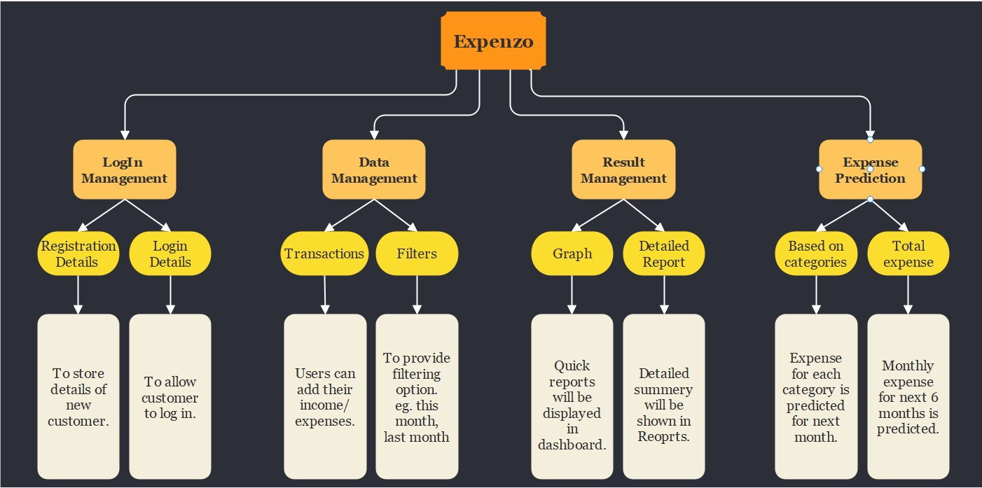

Figure 5.1: Block Diagram.

**Use Case Diagram:**

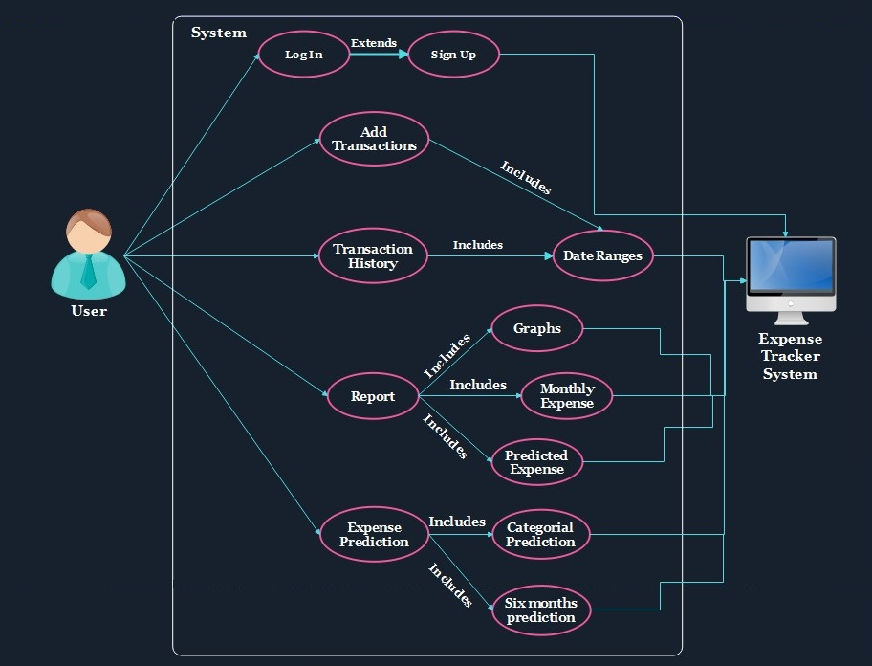

Fig. 5.2: Use Case Diagram

**CHAPTER 6**

**TECHNICAL SPECIFICATIONS**

**Development: VS Code**

VS Code also known as Visual Studio Code is a source code editor made by Microsoft for Windows, Linux, Mac OS. It has various features such as Debugging, Syntax highlighting, extension, intelligent code completion.

**Frontend: Html, CSS, JavaScript**

As a web developer, the three main languages we use to build websites are HTML, CSS, and JavaScript. JavaScript is the programming language, we use HTML to structure the site, and we use CSS to design and layout the web page. These days, CSS has become more than just a design language, though. You can actually implement animations and smooth transitions with just CSS.

**OS: Windows**

Windows is a graphical operating system developed by Microsoft. It allows users to view and store files, run the software, play games, watch videos, and provides a way to connect to the internet. It was released for both home computing and professional works.

**Backend: Python Flask**

Flask is a lightweight and popular web framework written in Python. It is used for building web applications and APIs quickly and easily. Flask provides tools, libraries, and patterns that allow developers to build scalable and secure web applications in a simple and elegant way.

**Database: Firebase**

Firebase is a mobile and web application development platform that provides a set of tools and services to help developers build high-quality apps. It includes features such as cloud storage, real-time database, authentication, and hosting, among others. Firebase is owned by Google and can be easily integrated with other Google services

**CHAPTER 7**

|  |  |  |
| --- | --- | --- |
| **Date** | **Weeks** | **Contents** |
| 13/01/2023 TO  18/01/2023 | 1 | Group formation and Topic finalization. Identifying the scope and objectives of the Mini Project |
| 20/01/2023  TO  26/01/2023 | 2 | Identifying the functionalities of the Mini Project |
| 29/01/2023  TO  3/01/2023 | 3 | Discussing the ML Algorithm. |
| 4/02/2023  TO  10/02/2023 | 4 | Designing the Graphical User Interface (GUI) |
| 17/02/2023  TO  17/2/2023 | 5 | Review 1 Presentations |
| 20/02/2023  TO  28/02/2022 | 6 | Detail ML Algorithm implementation |
| 03/03/2023  TO  10/03/2023 | 7 | Integration of GUI with ML Algorithm code |
| 14/03/2023  To  21/03/2023 | 8 | Report Writing |
| 20/04/2023  TO  20/04/2023 | 9 | Review 2 Presentations |

**PROJECT SCHEDULING**

**CHAPTER 8**

**IMPLEMENTATION**

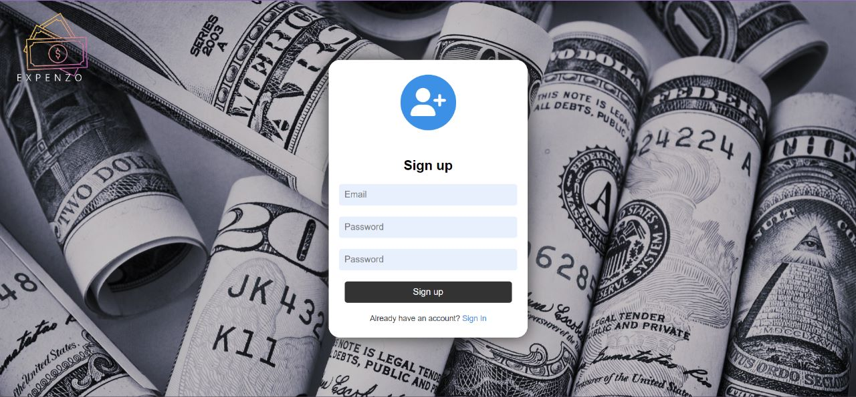

**Fig. 8.1: Sign Up Page**

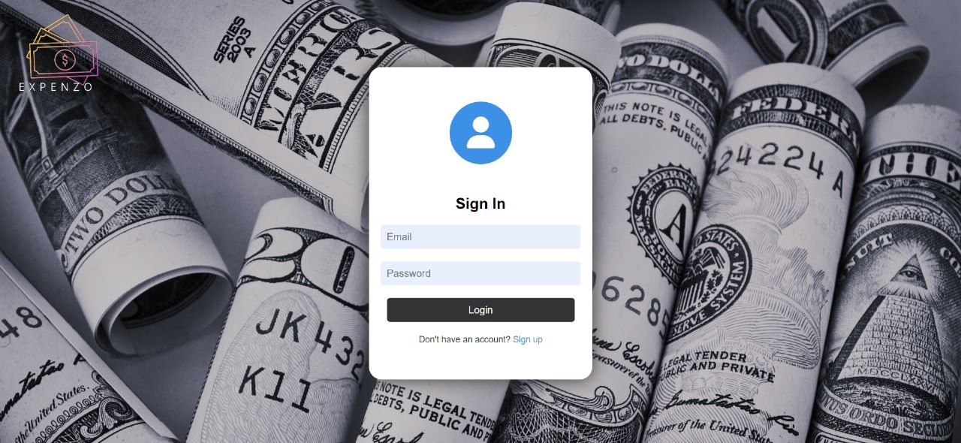

**Fig. 8.2: Sign IN Page**

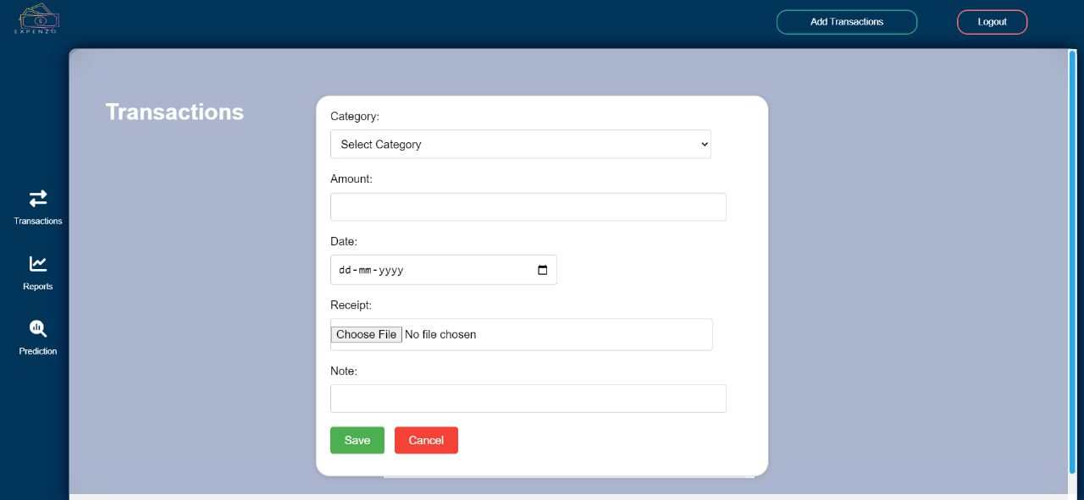

**Fig. 8.3: Add Transaction**

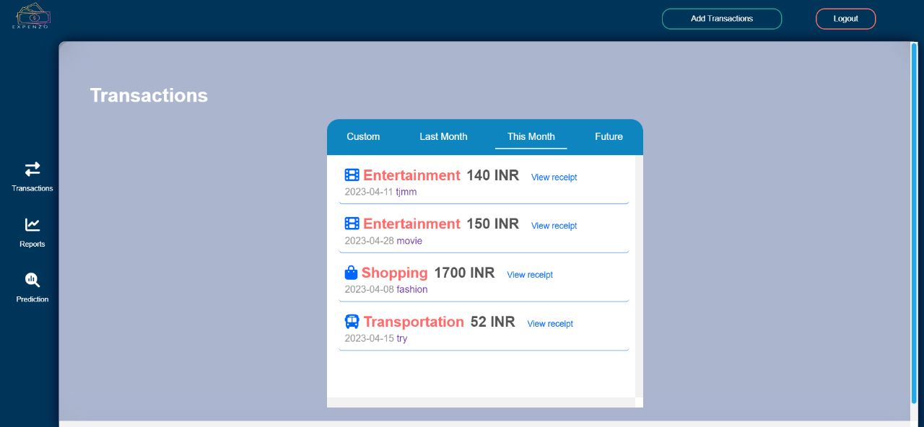

**Fig. 8.3: Transaction Page**

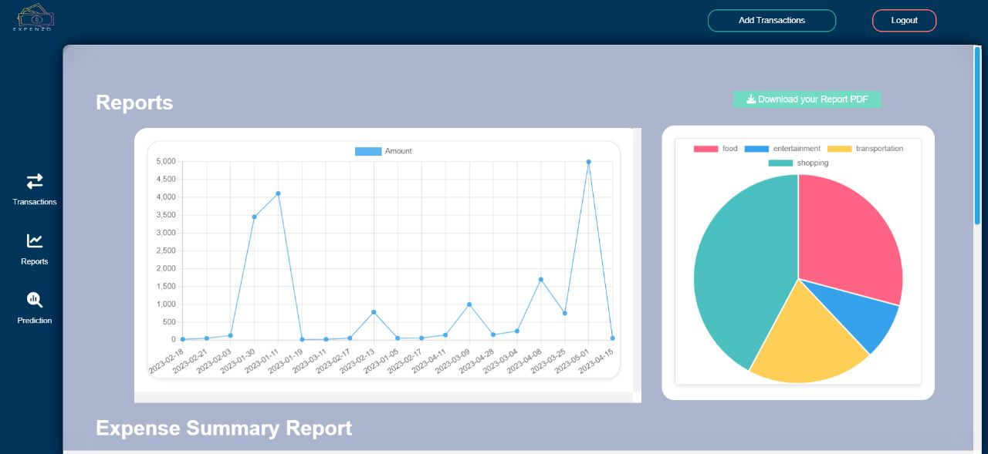

**Fig. 8.4: Report Page**

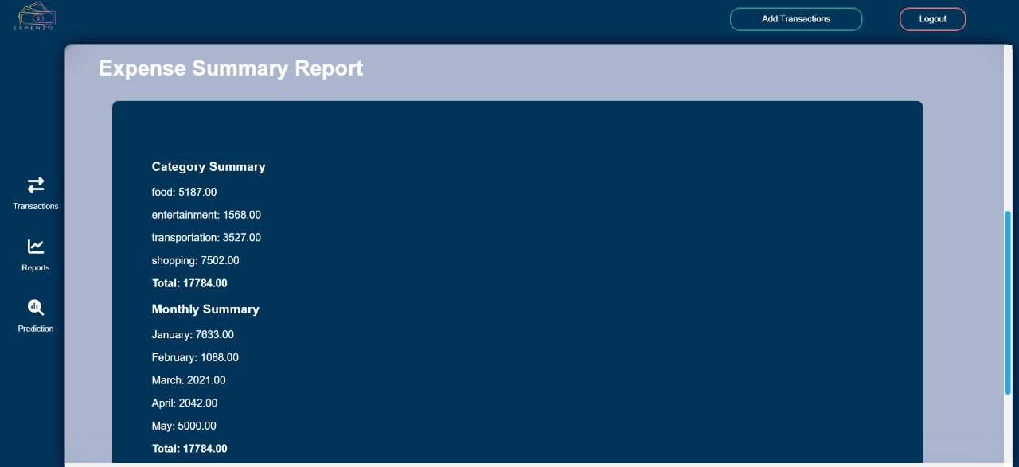

**Fig 8.4: Report Page**

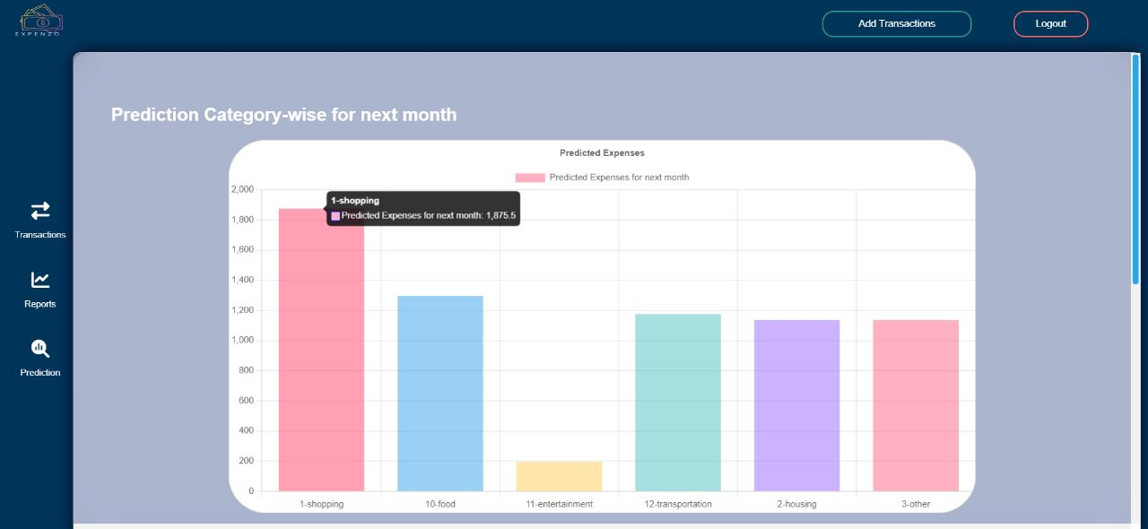

**Fig. 8.6: Prediction Page**

**CHAPTER 9**

**RESULT AND DISCUSSION**

* **Result:**

An expense tracking website with predictive capabilities helps users track their spending and provides insights into future expenses. By analyzing spending patterns and historical data, the website can predict upcoming expenses and help users make informed financial decisions.

**Some benefits of an expense tracking website with predictive capabilities include:**

1. Better financial planning: By predicting future expenses, users can plan their finances better and avoid surprises.
2. Increased savings: By tracking expenses and identifying areas where they can cut back, users can save money and achieve their financial goals faster.
3. Improved budgeting: By monitoring their spending and getting insights into their expenses, users can create more accurate budgets and stick to them.
4. Reduced stress: By having a clear picture of their finances and future expenses, users can reduce financial stress and anxiety.

An expense tracking website that predicts future expenses can help users to be more mindful of their spending habits and plan their finances accordingly. By analyzing a user's historical spending patterns and financial data, such a website can provide personalized insights and predictions about future expenses. This can include alerts for upcoming bills, expected expenditures based on past spending, and recommendations for how to better manage one's finances.

* **Discussion:**

An expense tracking website with predictive capabilities is an effective tool for managing personal finances. It helps users track their spending and provides valuable insights into their financial habits. By predicting future expenses, users can plan their finances better and make informed decisions about their spending.

**To get the most out of an expense tracking website with predictive capabilities, users should:**

1. Set financial goals: By setting clear financial goals, users can stay motivated and focused on their financial objectives.
2. Track expenses consistently: To get accurate insights into their spending, users should track their expenses consistently and in real-time.
3. Review spending regularly: By reviewing their spending regularly, users can identify areas where
4. they can cut back and save money.
5. Use the predictive capabilities: By taking advantage of the website's predictive capabilities, users can anticipate future expenses and plan their finances accordingly.

**Need for an expense tracking website with prediction capabilities:**

1. Many people struggle with managing their finances effectively, and often overspend or underestimate their expenses.
2. An expense tracking website with predictive capabilities can help users to be more proactive in managing their finances, and avoid unnecessary expenses or financial stress. By providing personalized insights and recommendations, such a website can empower users to make informed decisions about their spending habits and financial goals.

**Key features of an expense tracking website with prediction capabilities:**

1. Automated data analysis: The website should be able to automatically analyze a user's financial data, including transaction history, bank statements, and credit card statements, to identify spending patterns and trends.
2. Personalized insights and predictions: Based on the data analysis, the website should be able to provide personalized insights and predictions about future expenses, including upcoming bills, expected expenditures, and recommended spending limits.
3. Budget tracking and goal setting: The website should allow users to set and track their budget goals, and provide regular updates and alerts on their progress.
4. Integration with other financial tools: The website should be able to integrate with other financial tools, such as investment trackers or retirement calculators, to provide a comprehensive view of the user's finances.
5. User-friendly interface: The website should have a user-friendly interface that is easy to navigate and understand, with clear visualizations and reports to help users interpret their financial data.
6. Overall, an expense tracking website with predictive capabilities is a powerful tool for managing personal finances. It helps users stay on top of their spending and achieve their financial goals.

**Chapter 10**

**Conclusion and Future Scope**

**Conclusion:**

In conclusion, an expense tracker with prediction website can be a valuable tool for individuals looking to manage their finances more effectively. By allowing users to input their expenses and analyze their spending habits, such a website can help them make more informed financial decisions and take control of their money.

The prediction feature can be particularly helpful as it can provide users with an estimate of how much they are likely to spend in the future, based on their past spending patterns. This can help users plan their budgets more effectively and avoid overspending.

Overall, an expense tracker with prediction website can be a great resource for anyone looking to improve their financial well-being and make more informed decisions about their money.

**Future Scope:**

* Integration with financial institutions: The expense tracker can be integrated with the user's bank accounts and credit cards to automatically pull in transaction data, making it easier for users to track their spending.
* Social sharing: Integrating social sharing options can enable users to share their financial goals and progress with friends and family, creating a community of people who are working towards improving their financial health.
* Mobile app: Developing a mobile app for the expense tracker website can make it more accessible and convenient for users to track their expenses on-the-go.
* Personalized recommendations: The expense tracker can provide personalized recommendations to users based on their spending patterns, such as suggesting ways to save money or invest in a better way.
* Machine learning algorithms: The use of advanced machine learning algorithms can help the expense tracker to make more accurate predictions based on the user's spending patterns and historical data.

**References:**

1. Shivani Gupta, Pankaj Yadav, and Rajesh Yadav. "Predicting Future Expenses using Machine Learning." 2019 International Conference on Automation, Computational and Technology Management (ICACTM). IEEE, 2019. DOI: 10.1109/ICACTM.2019.8761543.
2. Ashok Kumar Sharma and Shilpa Choudhary. "Forecasting Daily Expenses Using Machine Learning and Data Analytics." International Journal of Control and Automation. Vol. 13, No. 3, pp. 266-280, 2020. DOI: 10.14257/ijca.2020.13.3.24.
3. Alina Mustafina, Andrey Somov, and Tatiana Baidyk. "A Personalized Expense Tracking System with Future Expense Prediction." 2021 IEEE International Conference on Computational Intelligence and Virtual Environments for Measurement Systems and Applications (CIVEMSA). IEEE, 2021. DOI: 10.1109/CIVEMSA51473.2021.9503471.
4. “Money Lover: Budget Planner, Expense Tracker - Apps on Google Play.” [Online]. Available: <https://play.google.com/store/apps/details?id=com.bookmark.money>
5. [Accessed: 21-Oct-2020].“AndroMoney ( Expense Track ) - Apps on Google Play.”

Available: https://play.google.com/store/apps/details?id=com.kpmoney.android